 SCHOOL *of* BUSINESS AND TECHNOLOGY

Department of Engineering and Aviation Sciences

**Smart Delivery**

**Kevin Harper**

**Eli Nbede**

**Montraz Oliver**

Advisor: Dr. Zhang

April 7, 2020

Design of Autonomous Food Delivery Vehicle

By

Kevin Harper, Eli Nbede, and Montraz Oliver

Submitted to the Department of Engineering and Aviation Sciences in partial fulfillment of the requirements for the degree of Bachelor of Science in Engineering at the UNIVERSITY OF MARYLAND EASTERN SHORE

Date

The author hereby grants the University of Maryland Eastern Shore permission to reproduce and distribute publicly, paper and or electronic copies of this document in whole or in parts.

Authors Kevin Harper, Eli Nbede, and Montraz Oliver

Signature

Date

Department of Engineering and Aviation Sciences

Certified by

**LIST OF CONTENTS**

**LIST OF FIGURES**

**LIST OF TABLES**

**ABSTRACT**

**CHAPTER 1. INTRODUCTION**

Autonomous self-driving vehicles are growing exponentially in popularity within new age technology. There are only a few level 5 self-driving vehicles that require no human activation to drive. These self-driving cars are being used to transport goods and people around the world. Furthermore the electric car is preferred more often because it offers economic, global, and environmental benefits. The car that we plan to design will deliver food to people autonomously.

**Background/Motivation**

On the campus of the University of Maryland Eastern Shore there are many students that worry about their next meal and how they are going to get hold of it. A college student has numerous responsibilities on their table that limits their ability to obtain in a necessary time. In most colleges’ freshmen are not allowed to have cars and people with cars must pay a lot of money for parking and fees. This limits the amount of college students with cars and increases the amount of college students walking around campus. The gruesome schedule of college students makes it hard for them to eat food when it's offered.

At the University of Maryland Eastern shore students are offered food at the locations including Students Service Center, Engineering & Aviation Sciences Complex, Hawk’s Nest, Waters Hall. In the Students Service Center they offer students plateau dining, and oasis staff dining. Often students argue and complain about the food they receive from the cafeteria. This leads them to eat the chic-fila food the university provides.

When college students are in their dorm after a long day of classes and stressful lecturing. They still must do homework and study for their classes. At that point they are tired of walking and going to get some food that is at least .4 miles away. Furthermore, during the school year there are not always clear and sunny days. Especially at UMES in the winter the weather can get rough. This will disable students from going outside and getting the food they need to satisfy their stomach.

“Among the 214 National Universities that reported these data to U.S. News in an

annual survey, the average percentage of students who brought cars to campus in the

2016-2017 academic year was 46.8 percent”.

**Objective**

Design an autonomous electric car that can deliver dining services around campus universities

**Design Requirements**

1. Carry up to eight pounds of food
2. Will deliver one meal at a time
3. Open and close of food compartment
4. Navigation
5. Speed of 5-10 mph
6. Detect and drive on the sidewalk
7. Detect crosswalk
8. Detect Objects
9. Website Application
   1. Payment System
   2. Ordering System
   3. Food Tracking
   4. SMS

**Design Constraints**

1. Tires might not be able to withstand certain road conditions
2. Driving in rough weather conditions
3. System is incapable of going up stairs or ramps
4. Driving on roadways

**CHAPTER 2. PROJECT DESCRIPTION**

**System Description**

The core system of the electric car is the raspberry pi that is interfaced with the camera module, lidar sensor, and the Arduino. The driving parameters from the camera and lidar such as object detection and lane detection is sent to the Arduino. The Arduino uses the parameters from the raspberry pi to control the car. Also the Gps is interfaced with the Arduino to send and receive location parameters from the website location. The arduino uses those gps commands to drive the car to the designated location. Arduino will notify the website when a designated location is achieved through telemetry, so it can then send an SMS to the recipient.

**System Diagram (or Flow Chart)**

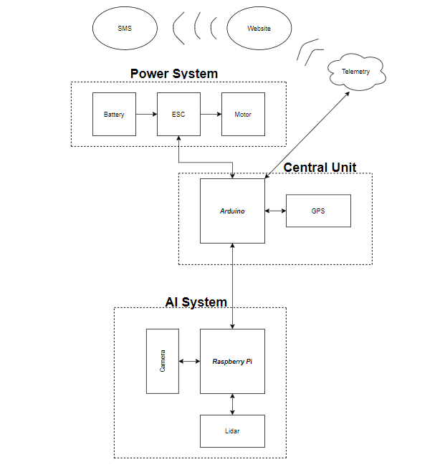

**CHAPTER 3. IMPLEMENTATION PLAN**

**Tasks**

Task1: Vehicle Structural Design

Subtask 1.1: CAD of Structure

Subtask 1.2: Implement Structure

Subtask 1.3: Design Lock System

Task 2: Design Electrical Power System

Subtask 2.1: Identify electrical components

Subtask 2.2: Connect Components

Subtask 2.3: ESC Programming on Arduino

Task 3: APP Design

Subtask 3.1: Create Ordering System

Subtask 3.2: Design Payment System

Subtask 3.3: Design Food Tracking System

Subtask 3.4: Design SMS

Task 4: Design of the Deep learning System

* Subtask 4.1: Gather Training Data
  + Camera: Capture Images
  + Annotator: Annotate Images
* Subtask 4.2: Train model
  + GPU: Pre-Processing
  + GPU: Model Training
* Subtask 4.3: Deploy Pre-Trained Neural Network
  + Raspberry Pi Camera: Capture Image
  + Raspberry Pi: Predict Image
* Subtask 4.4: Send Control and Steering Commands
  + PID Controller
  + Design Serial Protocol

Task 5: Design Lidar System

Subtask 5.1: Design Program for LiDAR sensor

Subtask 5.2: Design connection for LiDAR sensor

Subtask 5.3: Send control and steering commands

Task 6: Navigation

Subtask 6.1:Extract Geographic Coordinate Units

Subtask 6.2: Program GPS on Arduino

Subtask 6.3: Program Compass on Arduino

Task 7: System Testing, evaluation, and enhancement

Subtask 7.1: Test Design Requirements

Subtask 7.2: Evaluate and apply changes if necessary

Subtask 7.3: Repeat process

**Team Organization**

*3.2.1* ***Responsibility of Kevin Harper***

Task 1, Task 2, Task 5, Task 6 Task 7

*3.2.2* ***Responsibility of Montraz Oliver***

Task 1, Task 4, Task 5, Task 6,Task7

*3.3.3* ***Responsibility of Eli Nbede***

Task 1, Task 3, Task 5, Task 6, Task 7

**Timeline/Milestone/Delivery Plan**

**Table 1. PROJECT TIMELINE AND DELIVERY PLAN**

|  |  |  |  |  |
| --- | --- | --- | --- | --- |
| Time | Tasks | | | Comments |
| Montraz Oliver | Eli Nbede | Kevin Harper |
| Week 1-3 | Subtask 1.1 | Subtask 1.1 | Subtask 1.1 |  |
| Week 4 -7 | Subtask 4.1 | Task 3 | Subtask 2.1, 6.1 |  |
| Week 8 - 11 | Subtask 4.2 & 5.1 | Task 3 | subtask 5.1 |  |
| Week 12-13 | Subtask 1.2, Subtask 5.2 | Subtask 1.3, Task 3 | Subtask 1.2 ,Subtask 2.2 |  |
| week 14-16 | Subtask 4.3-4.4 | Task 3  Subtask 2.3 | subtask 6.2  subtask 2.3 |  |
| week 17-18 | Subtask 4.3-4.4 | Subtask 6.3 | subtask 6.3 |  |
| week 19-22 | Task 7 | Task 7 | Task 7 |  |

**CHAPTER 4. IMPLEMENTATION**

**Implementation of Task 1.**

*4.1.1. Implementation of Subtask 1.1*

*4.1.2. Implementation of Subtask 1.2*

*4.1.3. Implementation of Subtask 1.3*

*……..*

**Implementation of Task 2.**

*4.2.0 Implementation of Subtask 2.0*

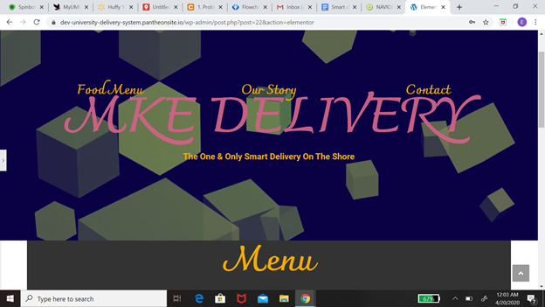

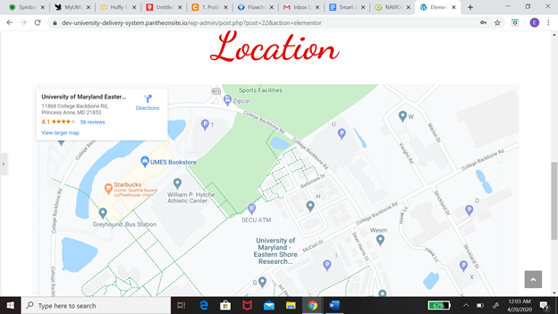

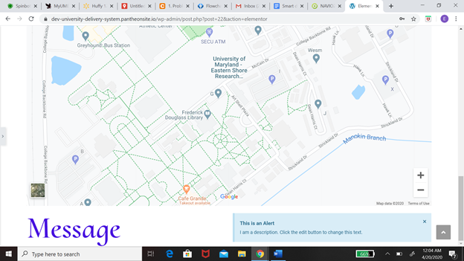

*The task at hand was basically designing a system where customers are able to order from and the employees are able to receive this order. This message from the customer will come with two key information one being the location of the customer and another being in the order that the customer please. My first solution with the problem at hand was to create a website using Pantheon. One of the mean reasons I chose pantheon was because it is User-friendly. We should allow me to come to the situation with no experience with this application. The approach I took from there was to design the function of the website which includes the menu, the contact information, location, and basket. The menu was based on the Chick-fil-A menu that is already online so all I needed was a plug-in but one of the problems I ran into while doing that was there is more than one restaurant on campus. So how would I be able to imply multiple menus on this website. After that, I worked on contact information which would include Our number. From there I want to create the location and the check out basket. I still had some consideration for the website which includes how to install more than one menu at a time and also have the GPS system track the food order. I was never able to add the Message system to the website before moving away from this idea.*

[*https://dev-university-delivery-system.pantheonsite.io/wp-admin/post.php?post=22&action=elementor*](https://dev-university-delivery-system.pantheonsite.io/wp-admin/post.php?post=22&action=elementor)

*4.2.1 Implementation of Subtask 2.1*

*The next path after leaving the website was to create a cell phone app. Some of the reasons why I decided to work with a cell phones app was that it is way more versatile. when it comes to adapt to different applications like the problem I have with the messaging system and including the map on the website. The next step to the solution would be to create an application just only for the customer. Features on this application would include placing orders, allowing payments sharing location, messaging System. I will be going in more detail about every single feature on this app but first I need to explain the steps and procedures the App will take to solve these problems. Now I'm going to explain my flow chart which basically shows my thinking process on creating the application. When you first open the application it's going to take you to the welcome page and on that page, it's going to include sign-in or sign-up. If you already have an account with us you will be able to sign in to the app. if not you will have the option to sign up. After you successfully sign in to the app it will take you to the homepage. The information that will be included on the homepage would be a restaurant, Shopping cart and you will be able to search the app from the homepage. Each option will take you to a different page. If you decide to click the restaurant page you would be able to select the restaurant you want to order from and once you do that it would take you to the menu on the restaurant. if you’re not satisfied there will be an if statement that will give you the option to take you back to the main restaurant page that has all the different choices. The next part of this app would be the payment which would include the information like credit or debit card information and name of the person who is buying the food if you have a promo you can also include that into Payment. From there it’s going to take you to a map of the campus and you will pick your location on the map. which would all be included in your messaging system and your receipt and all that information will be sent to the business you order from and you will receive a text saying the order is complete.*

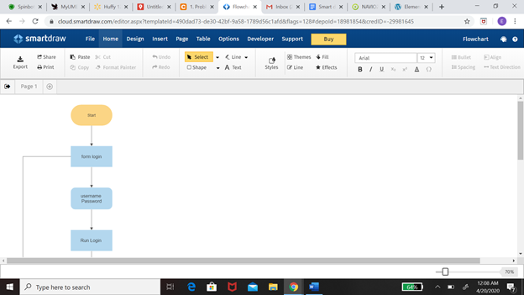

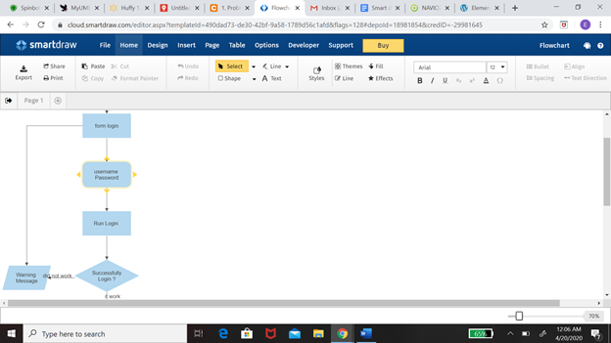

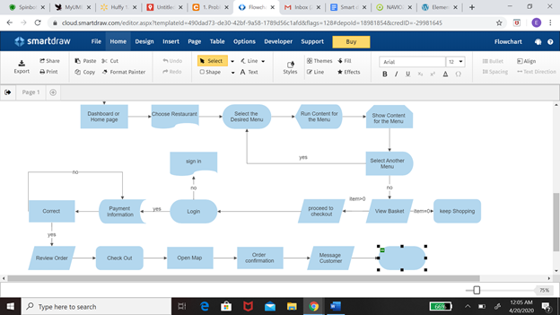

*4.2.2 Implementation of Subtask 2.2*

*4.2.3 Implementation of Subtask 2.3*

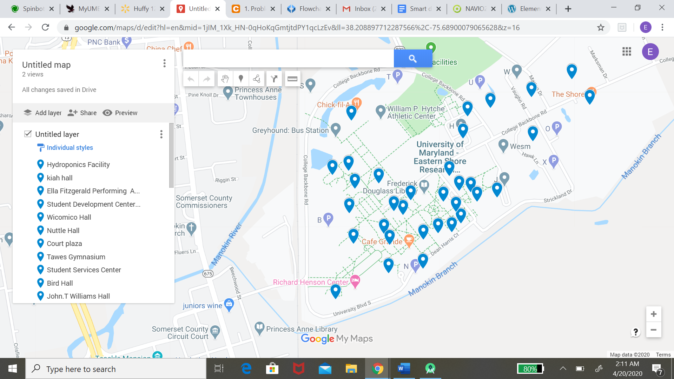

*4.2.4 Implementation of Subtask 2.4*

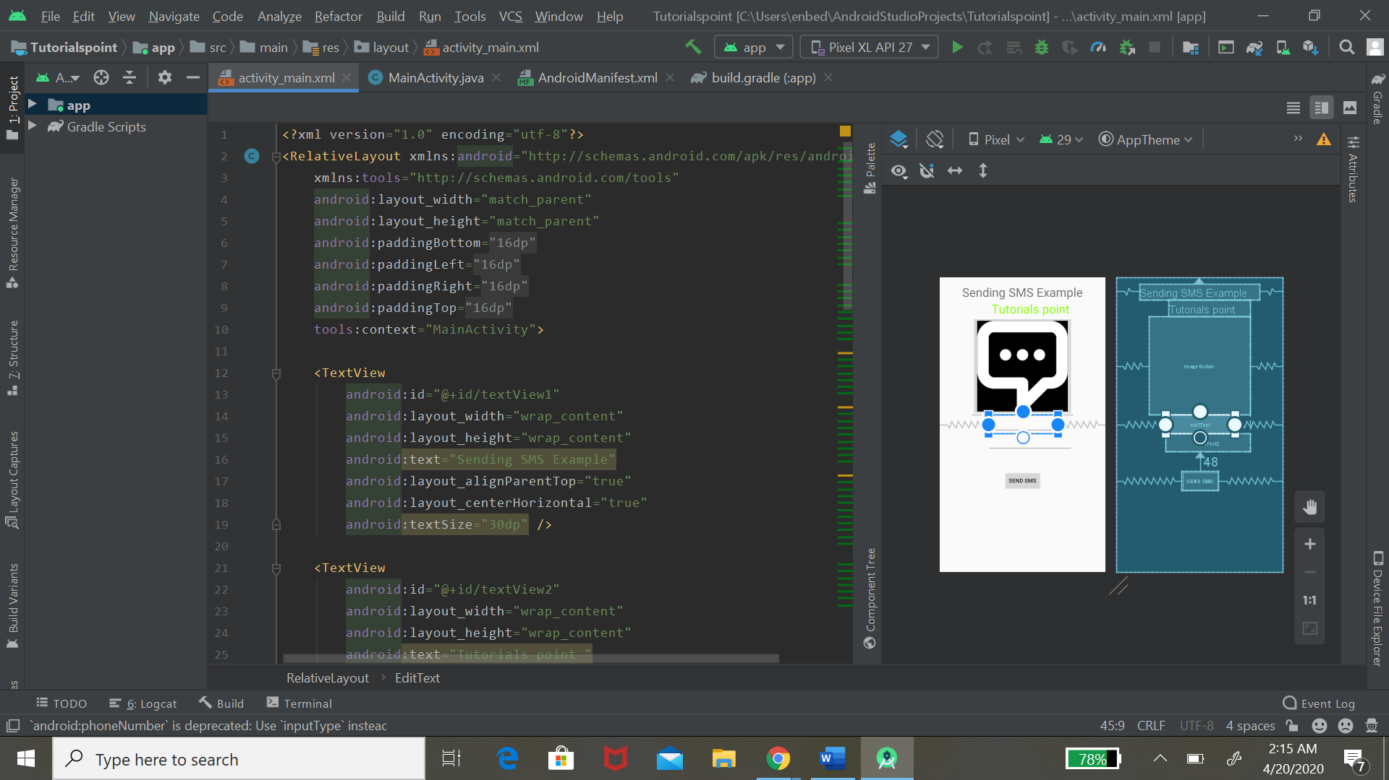

**Implementation of Task 3.**

*4.3.1 Implementation of Subtask 3.1*

*4.3.2 Implementation of Subtask 3.2*

*4.3.3 Implementation of Subtask 3.3*

**Implementation of Task 4.**

*4.4.1 Implementation of Subtask 4.1*

*Detected edges on the sidewalk via OpenCV: My initial approach was to detect the sidewalk edges in multiple frames with computer vision tactics. I worked on OpenCV in python for some time until I switched my focus to deep learning and building a neural network to detect the sidewalk.*

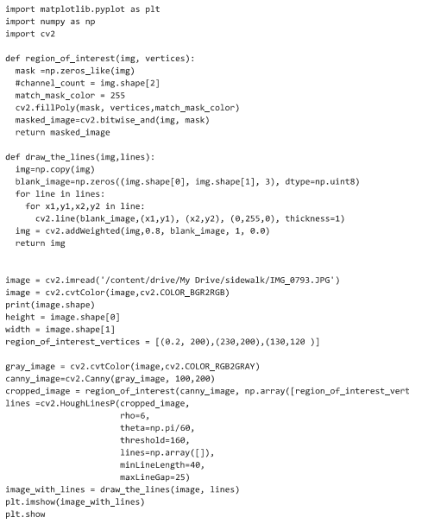

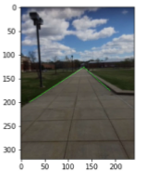

*Figure: Edge detection using OpenCV*

***Gathering Data:*** *My first subtask in the object detection deep learning process is to gain a lot of data to be able to train my neural network. Data includes at least 100-1000 images depending on the detection. Gathering data for object detection also includes annotating objects in an image. I have manually captured images with my Iphone camera, sent it to my pc and annotated each frame. This is a time consuming process that required me to gain knowledge on data science. After gaining the appropriate date needed my data has to be converted from a xml file to and tf record file.*

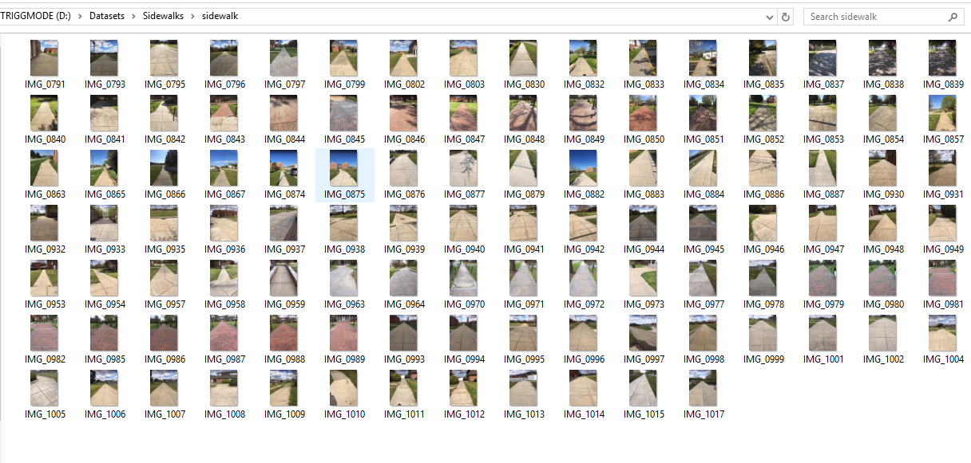

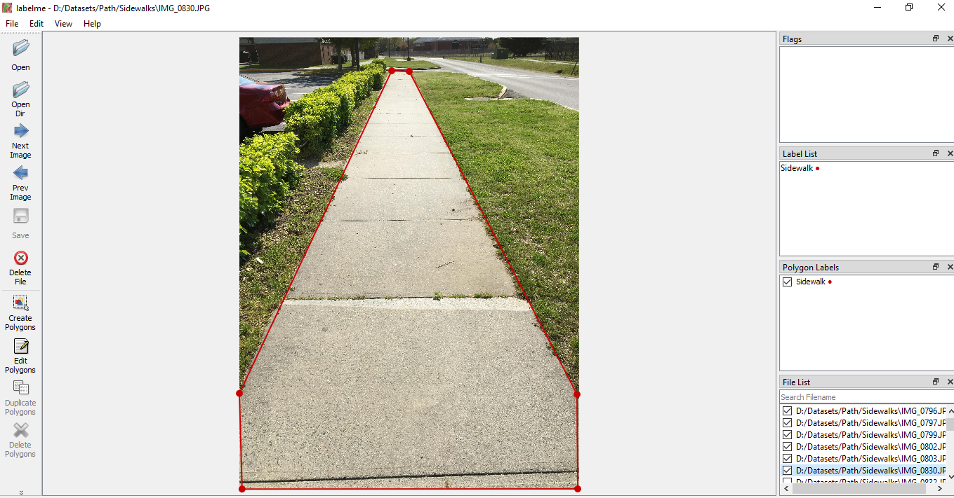

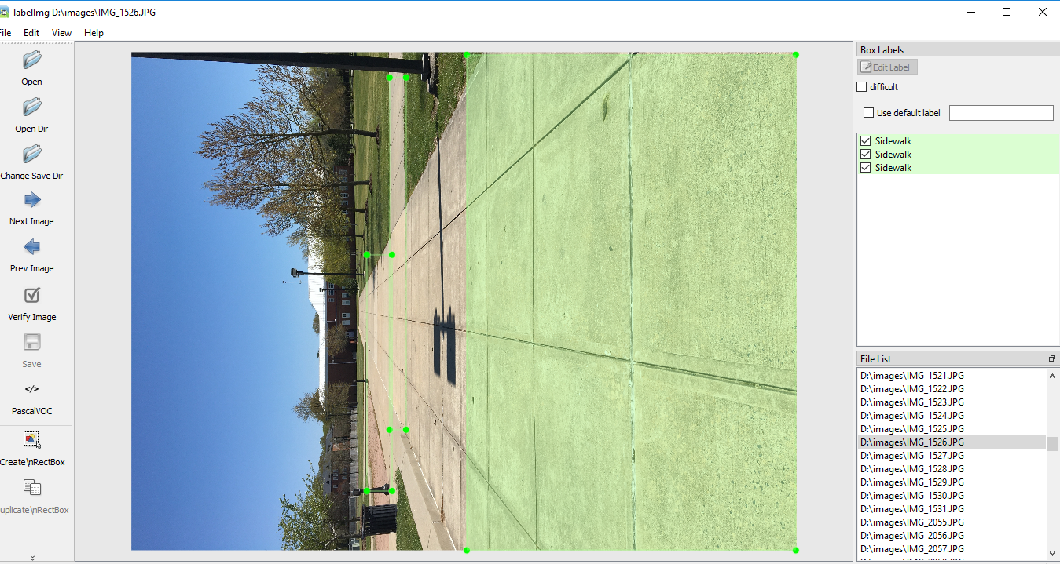

*Figur: Annotating Sidewalk*

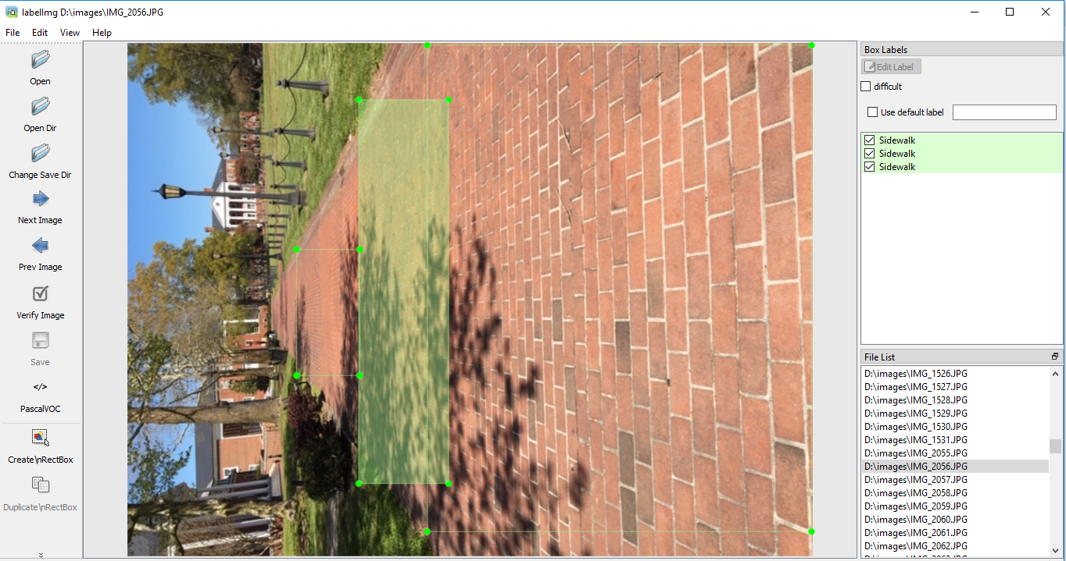

*Figure: Annotating Sidewalks*

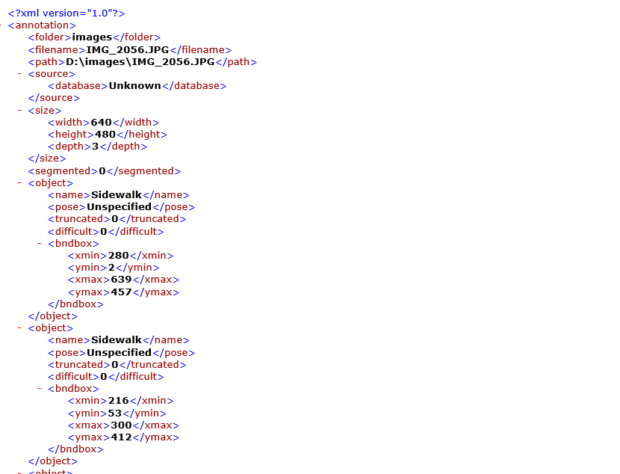

*Figure: XML file of annotated sidewalk*

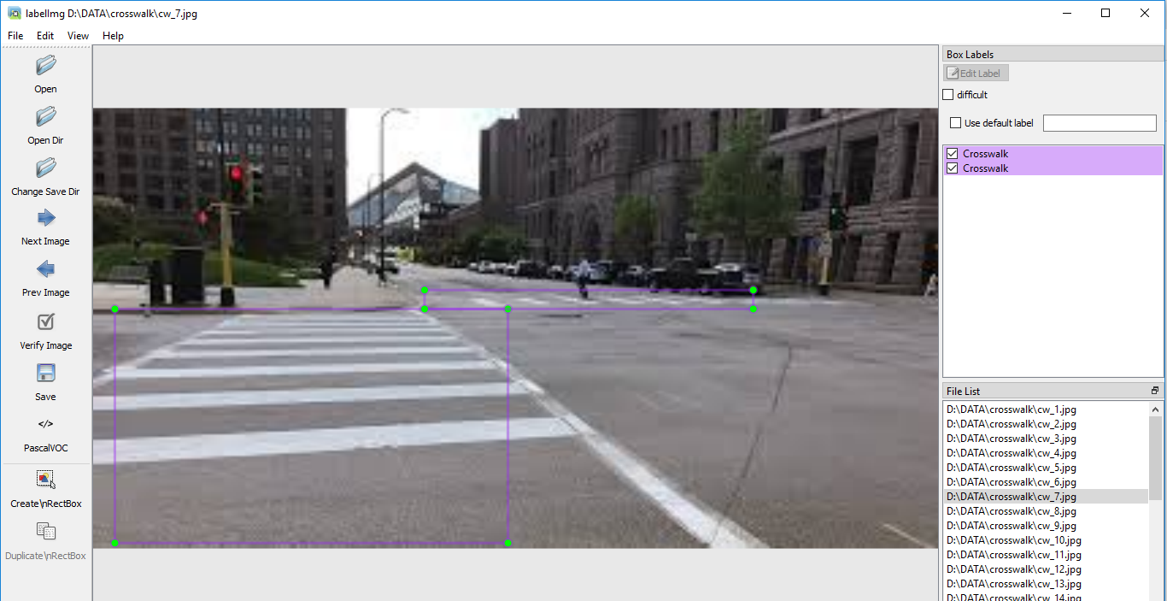

*Figure: Annotating Crosswalks*

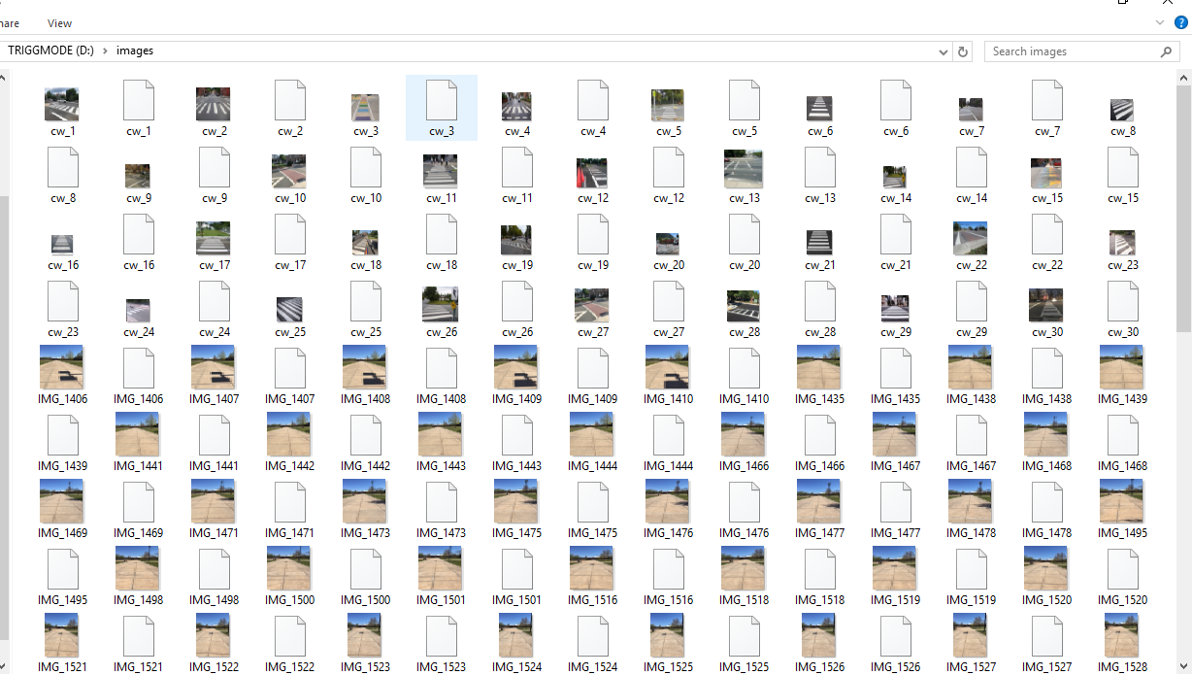

*Figure: Images and xml files*

*4.4.2 Implementation of Subtask 4.2*

*Learning and Starting Neural Network Design on Google Collab:*

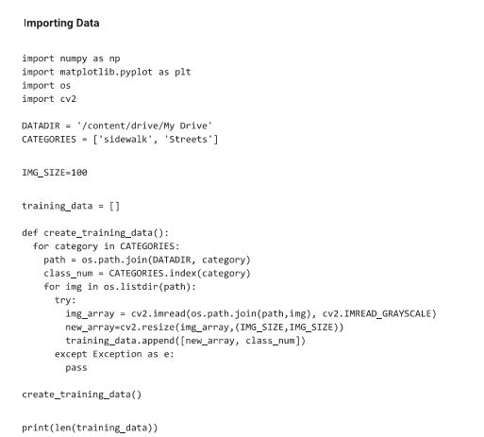

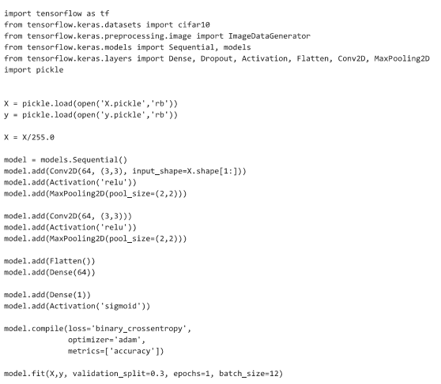

*4.4.3 Implementation of Subtask 4.3*

*4.4.4 Implementation of Subtask 4.4*

**Implementation of Task 5.**

*4.5.1 Implementation of Subtask 5.1*

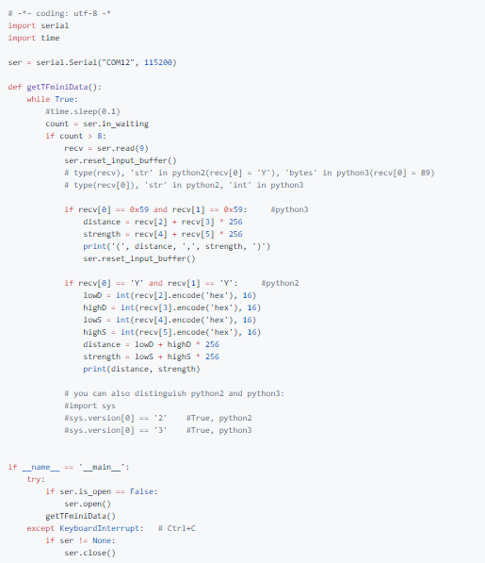 TFmini - RPi Connection code

*4.5.2 Implementation of Subtask 5.2*

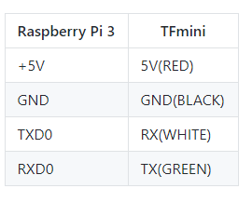 TFmini - RPi 3 Connection

*4.5.3 Implementation of Subtask 5.3*

**Implementation of Task 6.**

For task 6, the goal was to consider How this car is going to be able to navigate to where it needs to go to be able to make its food deliveries .

The first solution that I have looked into was adopting the ardupilot’s solution of the application “Mission Planner” . In mission planner , you have access to satellite maps from Google and Bing and then you can establish waypoints by clicking areas on the map, as seen in the picture i establish 5 waypoints on campus that our delivery vehicle can travel. The issues i came with is trying to run the simulation to test how the vehicle will travel along the waypoints and then return home

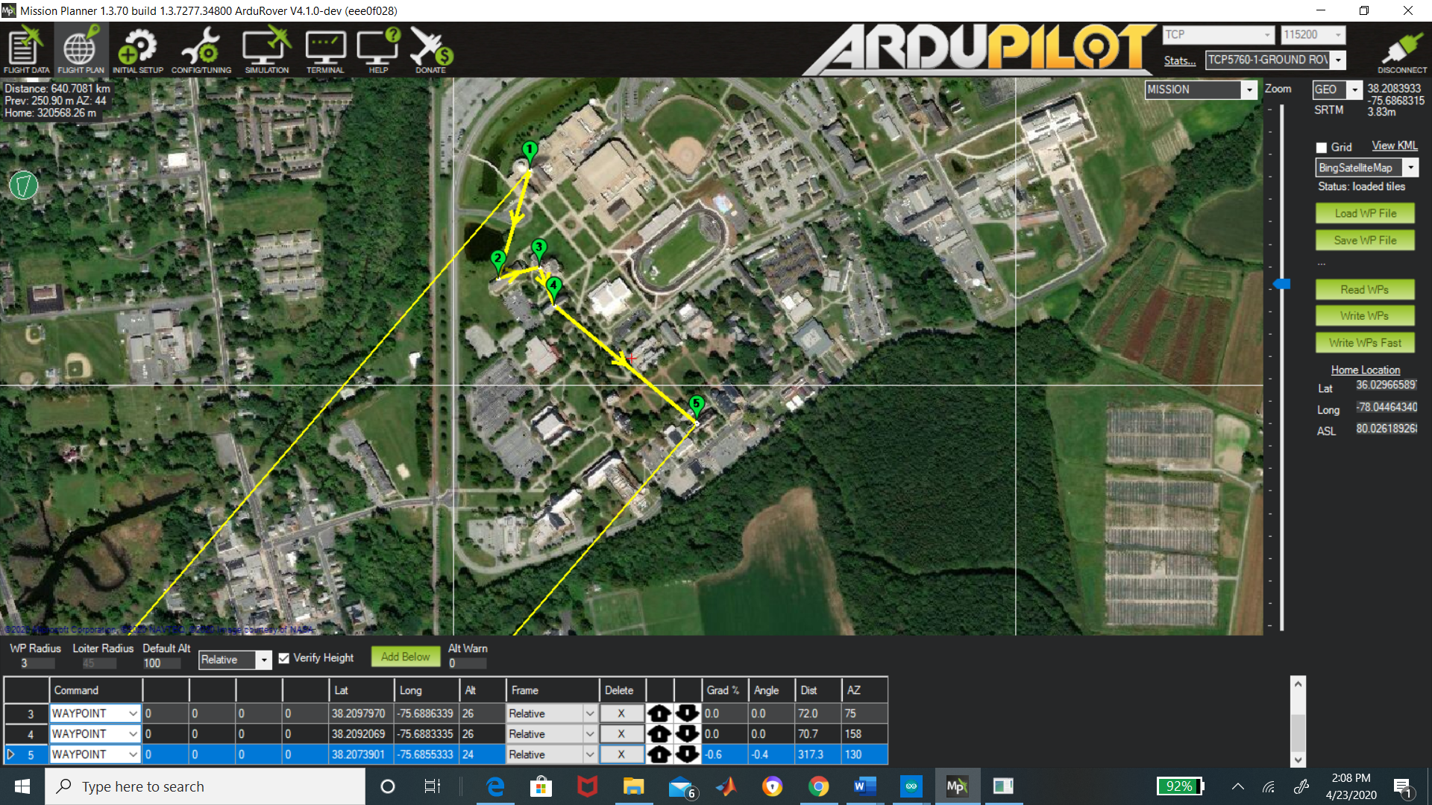

The other solution is accessing using google maps platform “Google API” . Google API gives you access to their satellite and the ability to create a set of waypoints/directions . you're allowed up to 25 waypoints for your personal use. In the code below, there is an example you can call upon these directions with your own personal “API” key. When I enter that code below, Google maps pulls up and then you can set the destination and also places in between that destination. For our vehicle, we want it to travel along the confines of campus, so with google api you can differentiate between if you want a “DRIVING” or “WALKING” route. we will use the walking route because that would avoid the car going on the road.

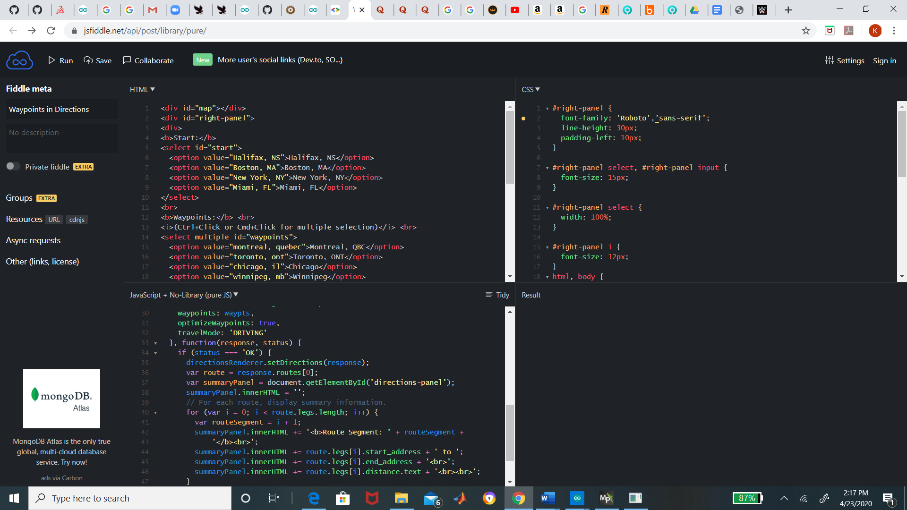

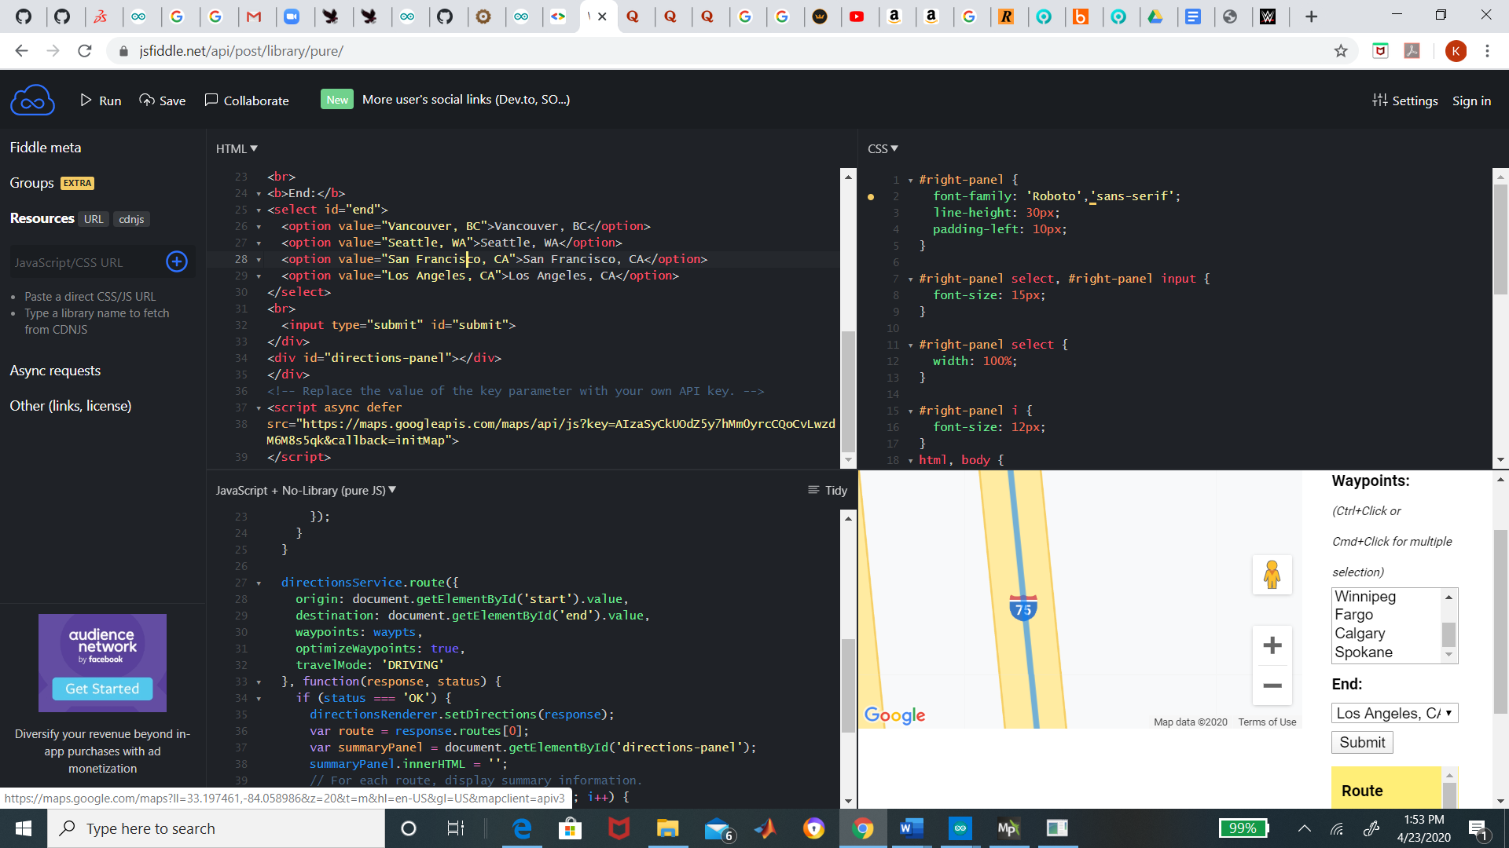

*4.6.1 Implementation of Subtask 6.1*

*4.6.2 Implementation of Subtask 6.2*

*4.6.3 Implementation of Subtask 6.3*

**Implementation of Task 7.**

*4.7.1 Implementation of Subtask 7.1*

*4.7.2 Implementation of Subtask 7.2*

*4.7.3 Implementation of Subtask 7.3*

**CHAPTER 5. PROJECT EVALUATION**

1. Public health
2. Safety
3. Welfare
4. Global Factor
5. Cultural Factor
6. Social Factor
7. Environmental Factor
8. Economic Factor

**CHAPTER 6. CONCLUSION**

**APPENDIX**

**REFERENCES**